Facial Quantum Matching Mirror
Team #8
Akhil Morisetty, Alex Cheng, Ethan Zhang
TA: Wesley Pang

Design Document for ECE 445 Spring 2026

Contents

1 Introduction 3
1.1 Problem 3
1.2 Solution 3
1.3 Visual Aid 4
1.4 High-Level Requirements 4
2 Design 5
2.1 Block Diagram 5
2.2 Physical Design 6
2.3 Display Unit Subsystem 6
2.3.1 Requirements and Verification 7
2.4 Startup Button Subsystem 7
2.4.1 Requirements and Verification 8
2.5 Power Unit Subsystem 8
2.5.1 Requirements and Verification 9
2.6 Backend: Database and Facial Recognition 9
2.6.1 Requirements and Verification 9
2.7 Tolerance Analysis 10
3 Cost and Schedule 11
3.1 Cost Analysis 11
3.2 Schedule 11
4 Discussion of Societal Impact, Engineering Standards, Ethics, and Safety Considerations 11
4.1 Positive Contribution 11
4.2 Engineering Standards 11
4.3 Ethical Concerns 11
4.4 Electrical and Mechanical Safety Concerns 11
4.5 Procedures to Mitigate Safety Concerns 11
5 Citations 11

1 Introduction

1.1 Problem
Chicago is spending 500 million dollars investing in the development of the Illinois Quantum and Microelectronics Park. Professor Kwait is looking for a viable prototype of a Facial Quantum Matching Mirror that he can show investors to persuade them into creating a more expensive and museum-ready version. Our task is to create a visually appealing and functioning prototype that Professor Kwait can show to investors to eventually add to the Illinois Quantum and Microelectronics Park.

1.2 Solution
We propose a Facial Quantum Matching Mirror, an interactive display device that uses a one-way mirror and facial recognition to reflect a user’s likeness matched with well-known figures in selected categories such as engineers, scientists, or entrepreneurs. When the display is illuminated, the one-way mirror becomes transparent, allowing the user to see the matched character overlaid behind the glass. This creates the illusion that the user is “face-to-face” with a figure who resembles them, combining reflection, computation, and visual storytelling in a single interactive experience.
The system consists of a one-way mirror, a display panel of equal size mounted behind the mirror, a surrounding LED light ring, a camera, local storage, a microcontroller, and a user input button, all integrated within a single frame. When the system is idle, the display remains dark, causing the mirror to behave as a reflective surface so the user sees only their own reflection.
Upon pressing the button, the user selects a category, and the system is activated. The microcontroller triggers visual feedback through the LED ring and commands the camera to capture an image of the user. This image is processed by the facial recognition backend, which identifies the most visually similar individual from the selected category. The result index is returned to the microcontroller, which retrieves the corresponding image from local storage and displays it on the screen.

1.3 Visual Aid
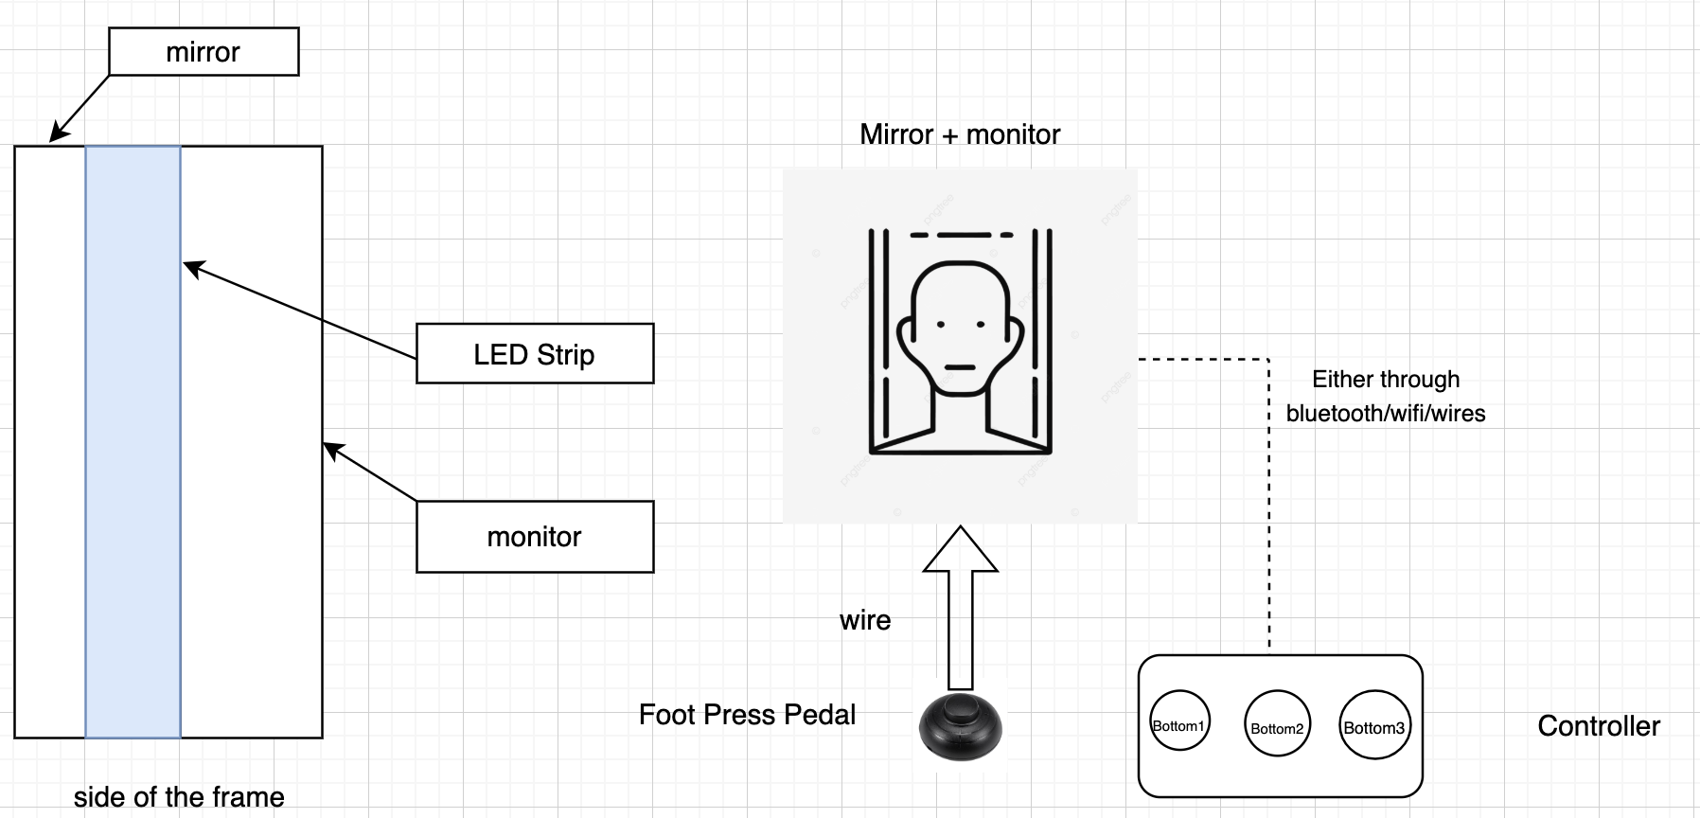
Figure 1: Visual Aid of Each Project Component

1.4 High-Level Requirements
- The system should complete the full single-user interaction cycle (LED illumination -> image capture -> facial matching -> display result) within 20 seconds of user activation
- While the monitor is not displaying anything, the mirror should have 70% reflectivity and give the visual effect of a mirror, and when the monitor is on, the monitor screen should be visible even under 30% reflectivity.
- The facial recognition model should return a visually accurate match that achieves at a minimum an 85% accuracy compared to a baseline recognition. (As of right now, we believe baseline recognition should be a group of 3 or more human TAs).

2 Design

2.1 Block Diagram

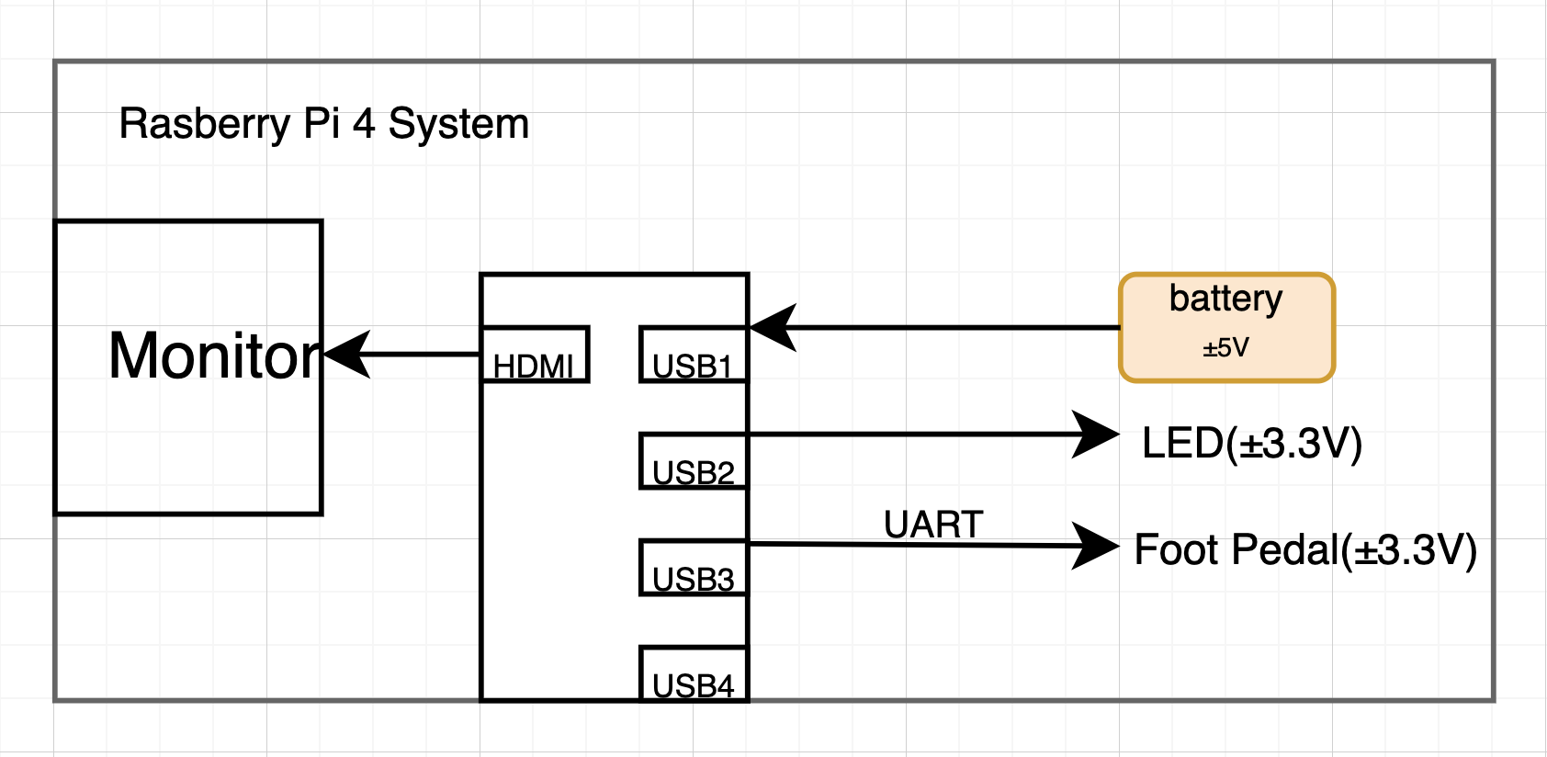
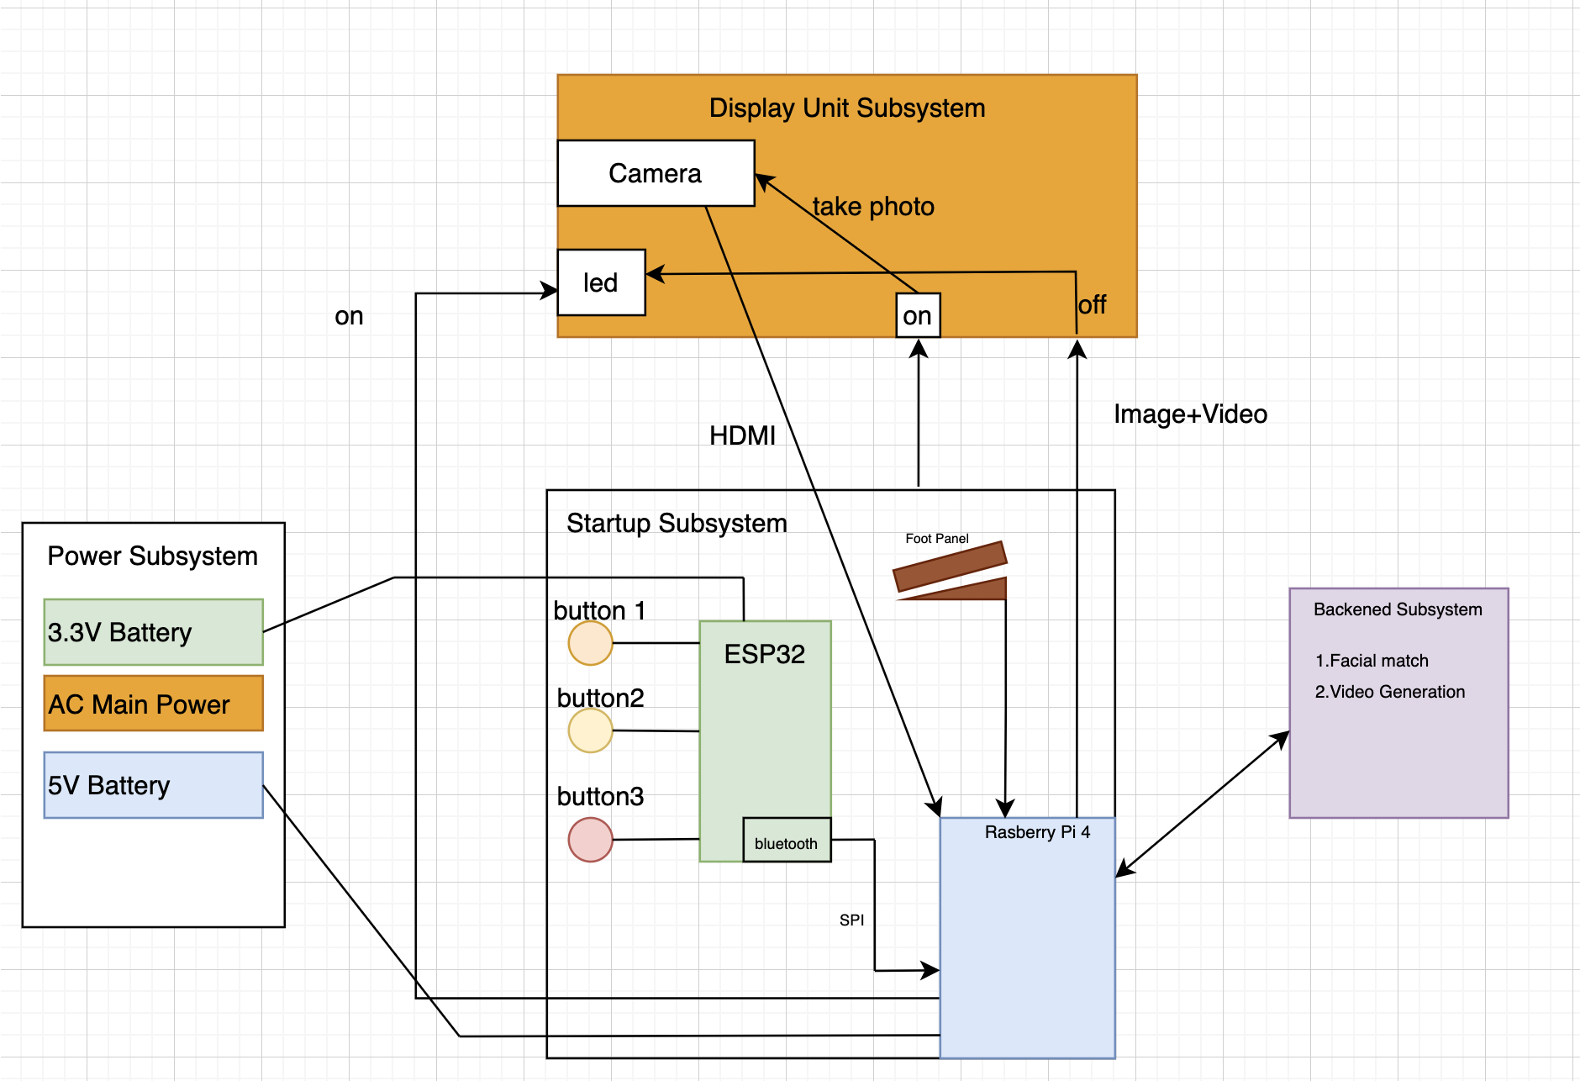
Figure 2: Quantum Mirror Block Diagram of all subsystems
The critical subsystems in the block diagram include the power subsystem, display unit subsystem, startup subsystem, and the backend subsystem. The power subsystem is the power unit for the entire system, and its role is to provide the necessary power to each of the components to ensure functionality. The display unit subsystem is responsible for displaying the results from the facial matching and holding up the monitor and led on its frame. The startup subsystem is responsible for getting the user input on which category to search from and signaling to the Raspberry Pi to begin the facial matching process. The backend subsystem is the entire codebase that is programmed onto the Raspberry Pi to do the facial matching with the image taken from the camera on the display unit subsystem. The result of the facial matching is then displayed on the monitor.

2.2 Physical Design
.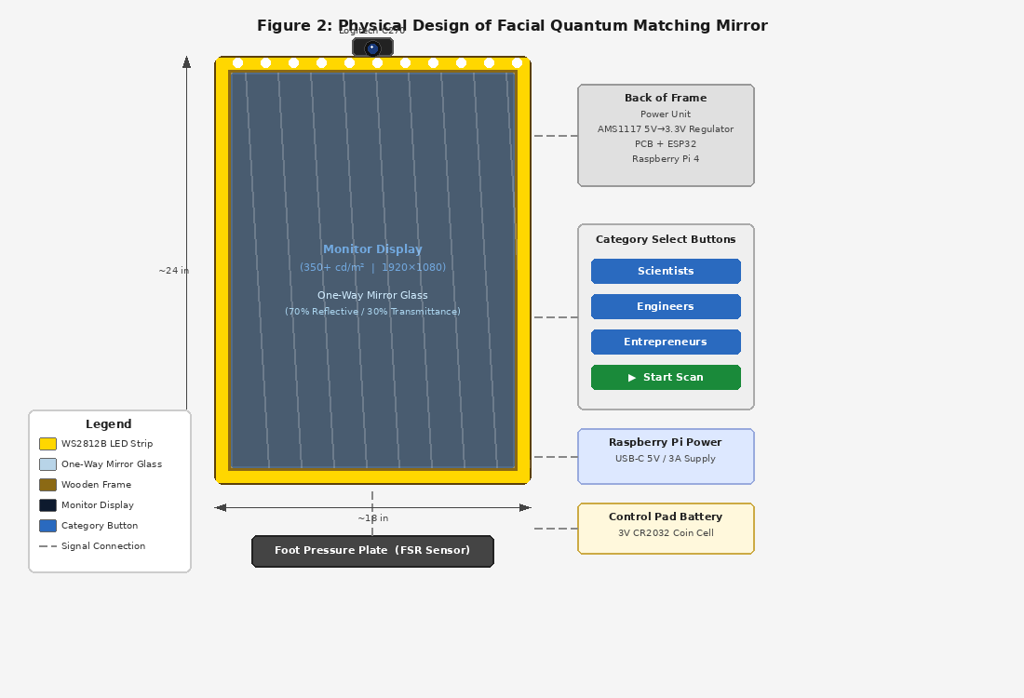
Figure 3: Physical Design

2.3 Display Unit Subsystem
This subsystem serves as the user interface layer of the smart mirror and is responsible for capturing the user’s image and presenting the final matched result. It consists of a Logitech C270 HW webcam, a monitor with a minimum max brightness of 350 cd/m², a 70% reflective glass mirror, a WS2812B LED strip operating at 3.3V, all mounted within a wooden frame.
In idle mode, the monitor remains off so the 70% reflective glass can act essentially as a mirror. During system initialization, the monitor will create enough luminance to be visible even through the glass that will have 30% transmittance. When the user activates the system through the startup subsystem, the ESP32 sends a signal to turn on the LED trip around the frame’s perimeter, providing a visual effect that the system is active. At the same time, the Raspberry Pi will trigger the USB camera mounted at the top of the frame to capture an image of the user’s face. This image will be sent to our backend subsystem for facial recognition processing. During image processing, the monitor and LEDs will synchronously display a loading animation until the backend returns a closest match in our database.

Requirements | Verification
The camera on the display unit must be able to capture an image of the participant's head in < 3s of activation | - Set up trial testing upon camera activation to repeat every time a picture is taken.  - Use a timer that starts when the camera activation begins, and when the picture is taken  - Every trial should result in a picture being taken within 3 seconds.
The display unit must be reflective like a normal mirror while it is idle and on standby | - Place the mirror in different lighting to test in variable environmental conditions.  - When the display unit is in idle or standby, make sure the unit is reflective like a normal mirror
The LEDs must be visible and indicate a state of activation within 200ms of foot pedal activation | - Set up trial testing every time the foot pedal is activated, which repeats the state once LEDs are visible, and indicates a state of activation  - Use a timer for each trial to see if the LEDs are visible and indicate a state of activation within the 200ms requirement.
Table 1: Display Unit Subsystem - Requirements & Verification

2.4 Startup Button Subsystem
This subsystem focuses on the start of the entire process for the project. The participant begins the process of using the mirror by choosing options from a set of buttons available to them. Moreover, there will be a pressure plate for the participant to stand onto which sends a signal to the buttons to begin taking the input for sending. The participant will have the option of selecting the quantum category that they want, and starting the camera/scan process with another button. The participant has control over when they are interested in and when they start the process. The button will be attached to the frame of the mirror as a part of a microcontroller on a pcb, where, when the category is selected through the buttons, the microcontroller sends a signal to the computer backend for which category to filter for the face matching. The system microcontroller organizes and communicates between all the other subsystems in the project. All of the logic and transmission of data is handled by this subsystem. Moreover, the software component of the projects sends data back and forth between the microcontroller and itself. The system microcontroller is the overarching subsystem in the project, which essentially plays a role in every component of the solution. The microcontroller also uses its Bluetooth capabilities to communicate with the Raspberry Pi, sending and receiving data.
The startup button directly contributes to the high-level requirements because it provides the primary input from the participant and serves as the activation of the mirror, going through different states and resulting in an output to the user. The microcontroller directly contributes to the high-level requirements because it serves as a coordination between the buttons and the Raspberry Pi, which initiates the activation cycle to begin.
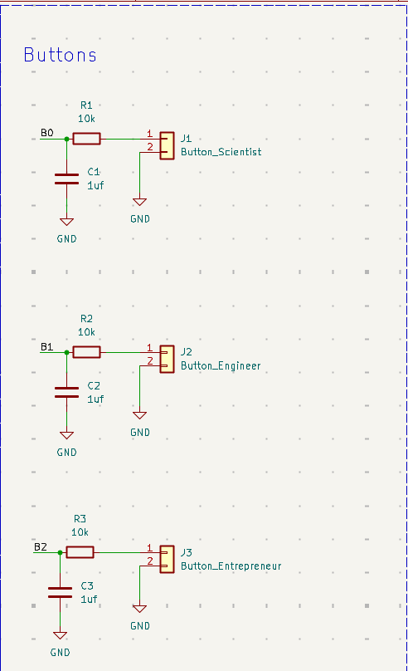
Figure 4: Startup Button Schematic

Requirements | Verification
The startup mechanism should register a valid activation signal within < 50ms of user foot contact | - Add a test led on the path from the foot pedal to the startup mechanism  - Every time foot contact is made, use a timer to track how long the signal takes to reach the startup button  - Use a timer to count how long the startup mechanism takes to register a valid activation signal
The startup mechanism should correctly detect activation in > 95% of presses during a 100-press test | - Press the foot pedal 100 times, taking a consistent time between each press  - For each of the presses, mark whether or not the startup mechanism detected activation  - Verify that the percentage of successful presses is >95%  - Repeat the procedure for 3 occasions
The microcontroller system must reliably receive user input signals from buttons and forward valid state data to the Raspberry Pi processing unit without loss in < 100 ms | - Press each of the user input buttons and record timestamps each time the button is pressed  - Record the time stamp when the Raspberry Pi received the data  - Verify that the difference between the two time stamps is <100ms  - Repeat process 20 times to ensure consistency
The microcontroller system must boot and enter operational state automatically when powered up without manual operations, and be able to operate continuously for 2 hours without communication failure or reset | - Power cycle the microcontroller and verify the booting process as it enter an operational state without manuel help  - Complete the power cycle process five times to verify consistency  - Have the system run continuously for 2 hours while sending input signal at regular intervals  - Verify no failures or rests occurred during the 2 hours
Table 2: Startup Button Subsystem - Requirements & Verification

2.5 Power Unit Subsystem
The power unit powers all of the components within the project. Our power unit will power the monitor, LEDs, and microcontroller. The control pad/startup button will be powered by a three-volt battery. The Raspberry Pi power module will be used to power specifically the Raspberry PI which has the backend software programmed onto it. The pressure sensor, which is part of the startup button subsystem, will have its own battery as well. The power unit for the monitor, LEDs on the display, and the microcontroller will be attached to the back of the frame. The power unit subsystem provides power to two major components: the monitor and the Raspberry Pi. ADD INFORMATION ABOUT 5 to 3.3V step down DC-DC linear regulator circuit that we added under the power unit subsystem

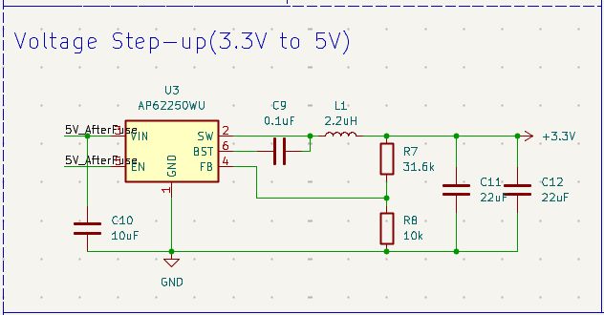
Figure 5: Power Subsystem Schematic
Requirements | Verification
The power unit must safely supply a stable 3.3 volts to our ESP-32 Microcontroller during peak usage | - Connect a multimeter to the voltage input pins.  - Run the ESP-32 when under the high load  - Record the voltage across 2 hours  - Verify that the voltage stays within 3.3V±.1V
The 5V to 3.3V step-down regulator must regulate the output voltage within ±.1V of 3.3V under all of the different load conditions | - Connect a multimeter to the regulator output  - Test under the different loads: no load, half load, and full load conditions.  - Record the voltage output for each part of the regulator  - Verify reading is between 3.2-3.4V
Table 3: Power Subsystem - Requirements and Verification

2.6 Backend: Database and Facial Recognition
This subsystem receives the captured user image from the Logitech camera and the selected category, computes a face embedding from that image using a pretrained and possibly fine-tuned recognition model. Those embeddings will then be compared to a local database of precomputed embeddings. The backend should return the closest matching match ID to the Raspberry Pi.
The backend: database and facial recognition subsystem performs all of the image processing and image matching to result in an output on the mirror and a matched image of the participant.
Requirements | Verification
The facial recognition system should return a match result within 10 seconds of image capture | - Capture a test image using the Logitech camera  - Start a time when the image is captured  - Stop the timer when the Raspberry Pi receives the matched result  - Repeat for 25 different images and verify that the results are returned in under 10 seconds
The system should achieve > 85% top-match accuracy per category using a defined validation image set | - Get ready a set of validation images of individuals with accurate matches for each category  - Run each of the images through a facial recognition system  - Verify whether the top returned image is the correct one for the validation set.
The database should correctly store and retrieve records with a near 100% success rate | - Add 50 test records  - Simulate data to try to retrieve each of the records in the database  - Record any retrievals that have failed or are incorrect  - Verify that all the records are retrieved
Table 4: Backend Subsystem - Requirements and Verification

2.7 Tolerance Analysis
An important aspect of the design that poses a risk to the successful completion of the project is how the two-way mirror operates. If the mirror operates successfully, the mirror should act like a reflective mirror when the system is idle, and when the system changes states, the mirror should be transparent to display the output image. Depending on various lighting conditions and other variable factors, the mirror poses a risk of not acting correctly for the design.

Optical Tolerance Analysis:
L = Lux of the environment that the mirror is placed in
R = mirror reflectance from the human perspective
T = mirror transmittance from the human perspective
B = brightness of the monitor
p = effective reflectance of the mirror
K = contrast factor

In our case, we plan to find a 70% reflective piece of glass, use a monitor with a minimum of 350 cd/m^2, and place our system in replicable museum lighting, which can be equated to bright indoor lighting. We are also going to assume the mirror will be reflecting clothes, skin, and interior building items under average indoor circumstances. K is a contrast factor that means how many times brighter the display is than the reflection for the users to be comfortable seeing the content on the monitor. Thus our variables become:

L = 500 lux | R = 0.7 | T = 0.3 | B = 350 cd/m^2 | p = 0.3 | K = 3

Since our glass will be 70% reflective, when the monitor is in idle state, there wont be any issues with the glass acting as a mirror. The hard part is determined when the monitor is at
350 cd/m^2 brightness into a 30% transmittance. For the monitor to be visible from the human perspective we need:

L-ambient = (L * p) / pi = (500 * 0.3) / pi = 47.7 cd/m^2
L-display >= (L-ambient * K * R) / T

L-display >= (47.7 * 3 * 0.7) / 0.3 = 333.9 cd/m^2

This indicates to us that in order to have our monitor be visible with a contrast factor of 3 under 500 lux lighting conditions, we need a monitor that has a brightness specification of around 340 cd/m^2. Obviously, the luminance of the environment, contrast factor, reflectivity, and transmittance will not be exactly similar to our numbers, but a rough estimate guarantees us that we need to find a monitor with a minimum 300 cd/m^2 brightness and glass with a maximum 70% reflectivity.

3 Cost and Schedule

3.1 Cost Analysis

3.1.1 Labor
On average, the UIUC ECE Graduate makes approximately $86,000/year. That comes down to $41/hour. Based on the formula: $41/hr × 2.5 × 60 hrs = $6,150 per person

Team Member | Rate ($/hr) | Multiplier | Hours | Total
Akhil Morisetty | $41 | 2.5 | 60 | $6,150
Alex Cheng | $41 | 2.5 | 60 | $6,150
Ethan Zhang | $41 | 2.5 | 60 | $6,150
Total Labor |  |  |  | $18,450
Table 5: Labor Costs

3.1.2 Parts

Description | Manufacturer | Quantity | Part # | Total
Raspberry Pi 4 Model B (2GB) | Raspberry Pi | 1 | SC15184 | $65.95
ESP32 WROOM-32 Development Board (WiFi + BT) | HiLetgo | 1 | ESP-WROOM-32 | $10.99
Logitech C270 HD Webcam (720p) | Logitech | 1 | 960-000694 | $29.99
WS2812B RGB LED Strip 5V, 16.4ft, 60LED/m | BTF-Lighting | 1 | WS2812B-5M | $15.99
18x24" Tempered Two-Way Mirror Glass (70% reflective) | SUPREMETECH | 1 | B09SBX9JS2 | $89.99
21.5" IPS Monitor, 350+ cd/m² | Samsung | 1 | S22D304 | $119.99
Thin Film Foot Pressure Sensor / FSR Pad | Garosa | 1 | FSR-PAD | $9.99
Raspberry Pi USB-C Power Supply (5V 3A) | Raspberry Pi | 1 | SC0218 | $8.00
AMS1117-3.3V DC-DC Linear Voltage Regulator (10-pack) | SUNKEE | 1 | AMS1117-3.3 | $5.99
Momentary Push Buttons 12mm (5-pack) | Generic | 1 | PBS-24B | $5.00
Lumber & hardware for wooden frame | Home Depot | 1 | N/A | $35.00
 |  |  |  | $414.87
Table 6: Parts

3.2 Schedule
Week | Task | Person
March 2nd | PCB Order | Everyone
 | Finalize PCB schematic for ESP32, voltage regulator, and button input circuit | Akhil, Alex
 | Review PCB design with TA and make final corrections | Everyone
 | Begin breadboard prototyping of foot pressure sensor and push button inputs | Ethan
March 9th | PCB Order | Everyone
 | Verify 5V to 3.3V linear regulator output with multimeter | Alex
 | Test ESP32 boot sequence and button signal transmission to Raspberry Pi | Akhil
 | Begin building wooden frame and mount monitor and one-way mirror glass | Ethan
 | Breadboard Demo - ESP32 receiving button input and sending signal to Raspberry Pi | Everyone
March 23rd | PCB Order | Everyone
 | Assemble and solder second-round PCB with ESP32 and voltage regulator circuit | Akhil, Alex
 | Mount Logitech C270 camera to frame and verify image capture pipeline | Ethan
 | Set up local facial recognition database with precomputed embeddings per category | Akhil
March 30th | Assemble and solder final PCB revision | Everyone
 | Integrate ESP32 with Raspberry Pi over Bluetooth — verify end-to-end signal flow | Akhil, Alex
 | Test full image capture → embedding computation → database match pipeline | Ethan
 | Mount WS2812B LED strip to frame and verify activation within 200ms | Alex
April 6th | Progress Demo | Everyone
 | Validate full interaction cycle: foot press → category select → image capture → match display | Everyone
 | Debug any communication failures between ESP32 and Raspberry Pi | Akhil
 | Verify facial recognition accuracy meets >85% threshold using validation image set | Ethan
April 13th | Run 100-press foot pedal test and verify >95% activation detection rate | Alex
 | Verify match result returned within 10 seconds across 25 test images | Ethan
 | Run 2-hour continuous operation test on ESP32 and power unit | Akhil
 | Refine wooden frame assembly, cable routing, and overall physical polish | Everyone
April 20th | Mock Demo | Everyone
 | Run full end-to-end system test under simulated museum lighting (500 lux) | Everyone
 | Fix any remaining bugs in software, hardware, or mechanical assembly | Everyone
April 27th | Final Demo | Everyone
May 4th | Final Report Submission | Everyone
Table 7: Schedule

4 Discussion of Societal Impact, Engineering Standards, Ethics, and Safety Considerations

4.1 Positive Contribution
The Facial Quantum Matching Mirror serves as an interactive bridge between complex science and public engagement at the Illinois Quantum and Microelectronics Park. By matching users' facial features with diverse STEM pioneers, the project fosters a sense of representation and inspires a new generation of innovators to see themselves in technical fields. Furthermore, the prototype functions as a critical proof-of-concept for the $500 million investment initiative led by Professor Kwiat, demonstrating how integrated engineering disciplines—such as facial recognition and optical physics—can be synthesized into viable, educational museum installations that benefit the local Chicago technological ecosystem.

4.2 Engineering Standards
The project adheres to rigorous technical and ethical benchmarks to ensure safety, fairness, and reliability. This includes compliance with IEEE Principle 1 for data privacy by ensuring all facial data is processed locally and immediately deleted, and ACM Principle 1.1 for social responsibility by maintaining a diverse database to prevent algorithmic bias. Hardware construction follows industry safety standards for tempered glass and electrical grounding to mitigate mechanical and fire hazards, while optical safety is maintained by limiting LED brightness and frequency to prevent photosensitive seizures. By integrating these standards, the system ensures a secure and equitable experience for all users at the Illinois Quantum and Microelectronics Park.

4.3 Ethical Concerns
The primary ethical considerations for this project center on user privacy and algorithmic fairness. To uphold IEEE Code of Ethics Section I.1, the system prioritizes the "safety, health, and welfare of the public" by ensuring that all facial biometric data is processed in real-time and purged immediately after each interaction, preventing the creation of a persistent surveillance database. Additionally, we address the risk of "automated prejudice" by curating a diverse matching database that represents various ethnicities, genders, and backgrounds in STEM. This commitment to inclusivity ensures that the mirror serves as an empowering tool rather than reinforcing existing biases, aligning with ACM Principle 1.4 to be fair and take action not to discriminate.

4.4 Electrical and Mechanical Safety Concerns
The project presents potential hazards including electrical short circuits from the power supply, overheating of the Raspberry Pi or monitor during continuous operation, and mechanical risks associated with the mirror housing. Specifically, the use of a one-way glass mirror poses a shatter risk if improperly mounted, while the electrical system must handle high-voltage monitor power and low-voltage sensor lines without interference or fire hazards. Additionally, improper ventilation within the enclosure could lead to thermal throttling or component failure, compromising the system's reliability in a public park setting.

4.5 Procedures to Mitigate Safety Concerns
To mitigate these risks, all high-voltage connections will be shielded in insulated enclosures with proper grounding to prevent accidental contact or electrical fires. We will utilize tempered or laminated safety glass for the mirror to ensure that it remains intact or breaks into dull pieces if impacted, and the entire structure will be securely bolted to a stable base. Thermal management will be addressed by integrating active cooling fans and ventilation grilles into the housing. Finally, the software includes watchdog timers and fail-safes to automatically shut down power to the display if abnormal temperature thresholds are detected, ensuring public safety and hardware longevity.

5 Citations
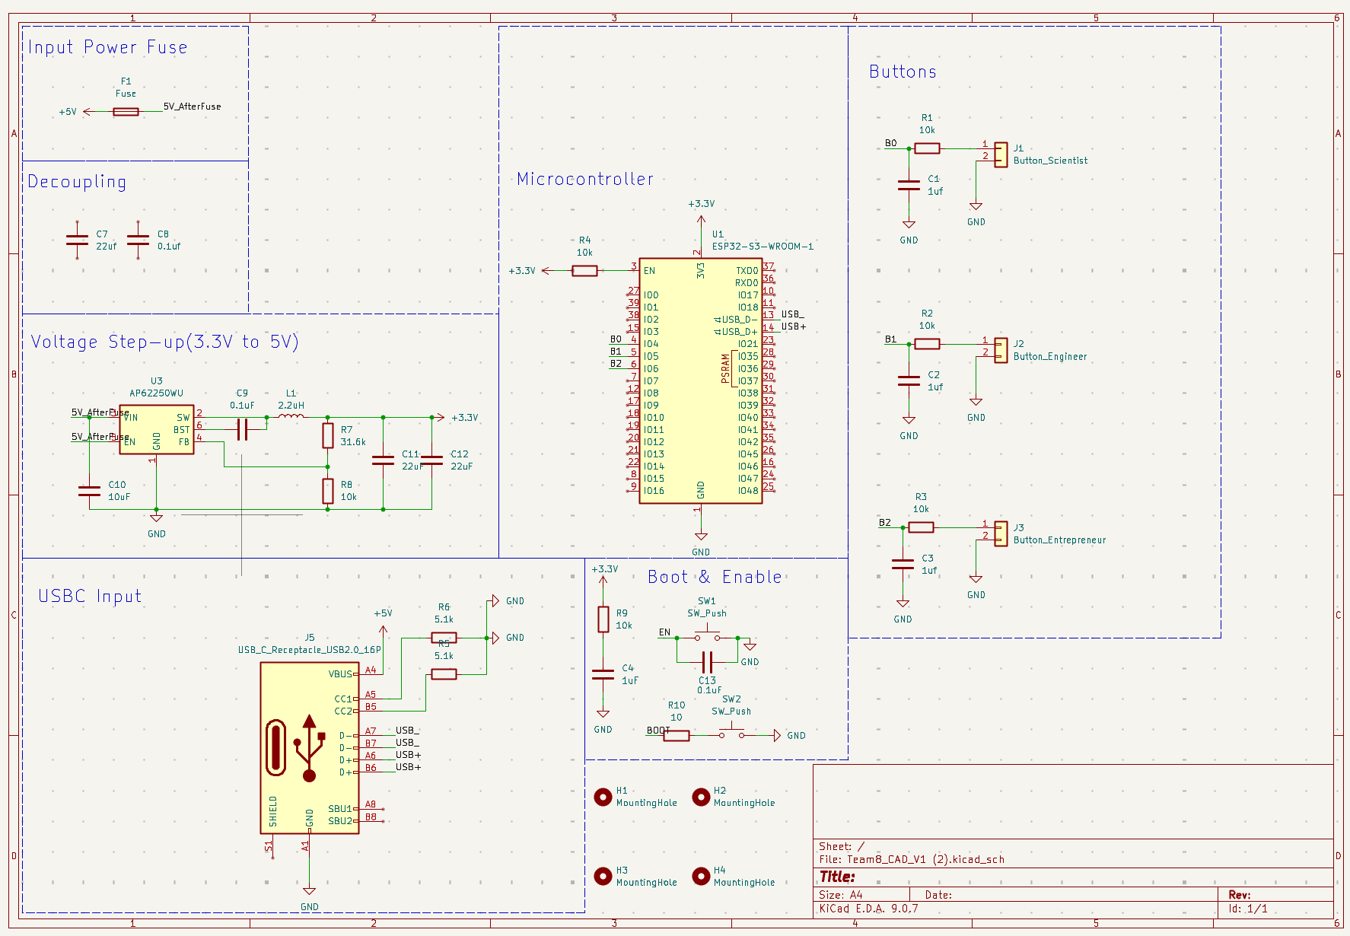
Figure 6: Entire Schematic

